Request for Information (RFP)
for
FARM TO SCHOOL
PROCUREMENT

Leland School District
408 East 4th Street, Leland, MS 38756

Director of Food Services: Clara Adams

Farm to School Coordinator: Ashley Watts

Last Revised: January 21, 2020

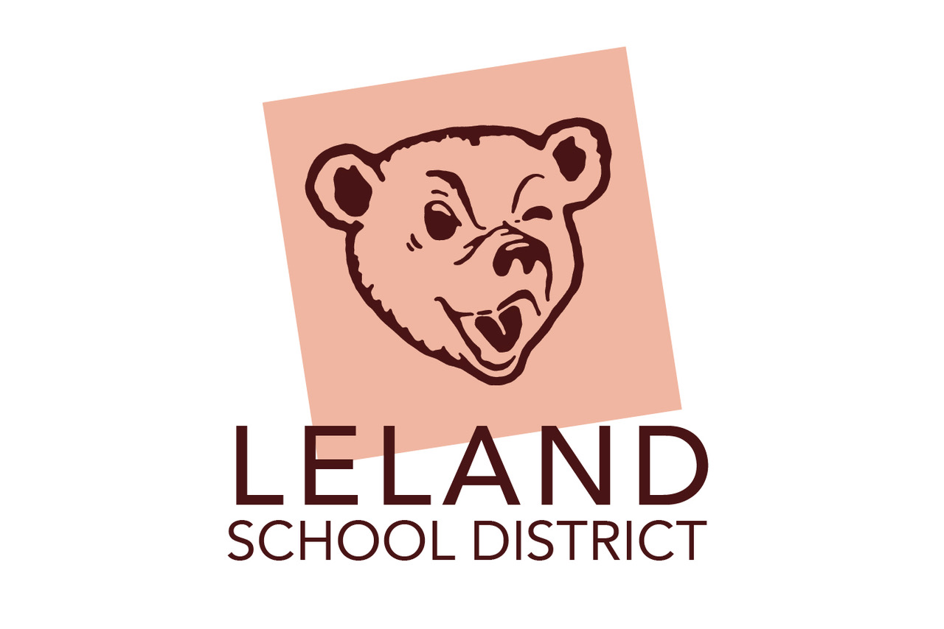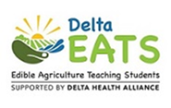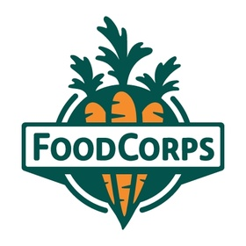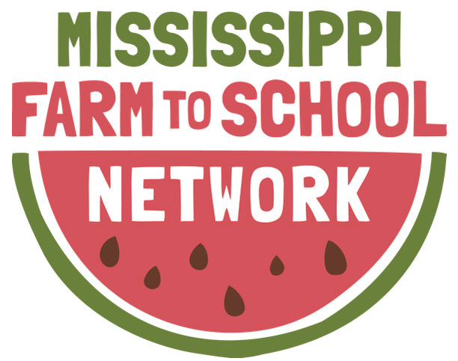

A. Project Objective/Background
Leland School District and Delta EATS are seeking proposals from farms/farm initiative co-ops wishing to provide Farm to School fresh produce items available locally and seasonally for the 2021-2022 school year.
Leland School District is a school district that is coterminous with the City of Leland Mississippi. The district covers Pre-K through 12 programs at four sites, with approximately 810 students and 125 teaching staff. Delta EATS (Edible Agriculture Teaching Students) is a school gardening program operated by DHA (Delta Health Alliance) in Delta elementary schools. A part of our program provides opportunities to our partnered districts like growing school gardens and cooking in an outdoor kitchen, participating students gain the knowledge and values necessary to make food choices that are healthy for them, their communities, and the environment.
One of Delta EATS objectives is to integrate Farm to School initiatives which connects farms to directly growing, selling and partnering with school districts to provide fresh fruit and vegetables for their menu and district wide taste test.
Leland’s School District Farm to School Program aims to provide fresh, high quality produce to students along with education about local food, nutrition and sustainable agriculture. The District is particularly interested in partnering with local small to medium sized farmers, beginning farmers, farms in which families own or control decision making on the farm, and farms owned or operated by minority and/or immigrant farmers.
The District defines “local” as within 600 miles of Mississippi. More information about the Nutrition Services and Farm to School Program can be found at website: https://lelandschooldistrict.schoolinsites.com/.
The District anticipates selecting multiple individuals and/or organizations to provide Farm to School fresh produce items. To facilitate the submission and evaluation of proposals, this request for proposals provides additional, relevant background information regarding Leland School District.
RFP Primary Objective 1: To identify vendor partners interested in collaborating with the District to grow its Farm to School Program in a way that is beneficial to the District and Farmers (Community, Financially and Stakeholder support).
RFP Primary Objective 2: Gain a thorough understanding of the supply available of high quality produce from qualified vendors in order to procure Farm to School Produce for the next school year or more.
RFP Primary Objective 3: Gain a thorough understanding of the Farm to School and produce proposed total costs for the next school year.
RFP Primary Objective 1: To identify vendor partners interested in collaborating with the District to grow its Farm to School Program in a way that is beneficial to the District and Farmers.
RFP Primary Objective 2: Gain a thorough understanding of the supply available of high quality produce from qualified vendors in order to procure Farm to School Produce for the upcoming school year.
RFP Primary Objective 3: Gain a thorough understanding of the Farm to School and produce proposed total costs for the next school year.

B. Schedule of Proposal
1. Issue RFI: Monday, February 1, 2021
2. Deadline for Written Questions: 4:00 PM Friday, February 19, 2021
3. Mandatory Pre-Bid Conference Call: 10:00AM Monday, February 22, 2021
4. Responses to Questions Posted: 4:00 Tuesday, February 23, 2021
5. Mandatory Intention to Submit Form Due: 12:00PM Monday, March 1, 2021.
6. Proposals Due: 4:00 PM Friday, March 26, 2021
7. Finalists Selected & Notified: Friday, April 2, 2021
8. Final Award Bid-Selection: Monday, April 12, 2021
9. Implementation: Monday, August 2, 2021.

In order for your organization to receive updates to this Request for Information, including responses to submitted questions, please complete the Intention to Submit a Proposal Form and/or submit your email to Farm to School coordinator contact below.
The District is hoping to receive applications in bulk, but we will be accepting ongoing applications until all fruit/vegetable vendors are contracted. This will allow the District to provide timely information to interested parties.
This form is a mandatory form. Questions about the Intent to Submit Proposal should be directed to Farm to School Ashley Watts at: awatts@deltahealthalliance.org or 662-390-3301.
C. Proposal Preparation
Applicants should ensure all appendix items are appropriately described, answered and referenced in the Response Form. All responses should include the following completed forms submitted in the appropriate order.
No cover letters will be accepted. Do not include a copy of this RFI with response.
a. Response Cover Page (See Appendix 1)
b. Response Form (See Appendix 2)
c. Pricing and Availability Form (See Appendix 3)
d. Appendix Materials (as needed, optional)

D. Circumstances that may lead to a response not being reviewed and/or selected:
a. Applicant’s previous clients/references have significant complaints regarding the quality of the Title
services, communication issues, or other problems.
b. Any section of the RFP is missing or incomplete.
c. The response does not meet length, font, or other formatting requirements.

E. Evaluation and Selection Process
1. The Farm to School School District Team will review proposals, responses, and references will be included as the Evaluation Committee recommends finalists for the District. Upon approval from the authorized District signer, the District will then proceed with contract discussions with the selected vendor(s). The District has no liability to any vendor participating in this RFI process prior to when the authorized District signer signs a contract to that vendor. Vendor selection will be evaluated based on the following:
- Food & Safety Practices
- Availability to Procure
- Competitive Competition Pricing

2. Proposal selections will be determined by the Evaluation Committee reaching consensus. The Farm to School Produce Evaluation Committee members will discuss to evaluate the responses to the questions outlined in this RFP.

3. Finalists will be informed of specific produce items awarded, and asked which items the finalist would like to move forward with to establish a contract. For example, if a finalist is ranked first for providing cucumbers, green peppers and carrots but is unable to provide all three, the first ranked organization may turn down the carrots and the next ranked organization for carrots will be awarded carrots.

F. Contract Negotiations
Negotiations may include all aspects of services and fees and may include further clarification of bid pricing. After a review of the proposals and any necessary follow up requests for information as deemed by the District, the District intends to notify finalists and enter into contract negotiations with the selected organization(s). If an agreement with the selected organization is not finalized within 90 business days, the District reserves the right to open negotiations with the next ranked organization(s).

G. Award of Contract
The District intends to make awards in part (by product) to multiple organizations; however, the District reserves the right to award in part or as a whole, whichever is deemed most
advantageous to the District.

This RFP and the proposal, or any part thereof, may be incorporated into and made a part of the final contract(s). The District reserves the right to negotiate the terms and conditions of the contract(s) with the selected Proposer(s). Vendors may propose their own contracts and terms subject to approval by legal counsel for the District.
.
J. Contract Term
It is the intent to award the contract(s) for an initial semester, January to May 2021 (1 semester term) with the option to renew it for an additional five month period (the following semester Summer, Fall/Winter, Spring) for a possible total contract term. The decision to renew the contract(s) will be at the sole discretion of the District and agreement by both parties.
Farmers must agree to fix contract fees for the first year. If the Farmer intends to revise its fee schedule after the initial five month semester period, it must give written notice to the District 90 days in advance of any fee change. Fees may be changed only on the contract expiration date with 90 days notice. These fees are subject to negotiation and approval by the District.

K. Disposition of Proposals
All materials submitted in response to this RFP will become the property of the District. All information submitted is considered public and may be disclosed to third parties.

J. Cost Incurred in Responding
This solicitation does not commit the District to pay any costs incurred in the preparation and submission of proposals or in making necessary studies for the preparation thereof, nor to procure or contract for services.

K. Causes for Termination
The District intends for contracts to be mutually beneficial to both the organizations and the District, and seeks to keep communication open and collaborative in order to mitigate causes for termination. Causes for termination of the agreement may include any of the following:

Failure to
- Promptly and faithfully provide the services required at the prices indicated in the Proposal
- Violation of any law governing services provided to the District;
- Failure to cooperate upon receiving any reasonable request for information, delivery or service;
- or if the farm is under a natural disaster clause which may cause a delay in harvest, delivery or production.
The District or vendor may terminate the agreement without cause on 90-days notice. The District or vendor may terminate the agreement with cause on 30 days notice.

SECTION II: SERVICE EXPECTATIONS

A. Project Background
This section begins with some background information on the District and then discusses the overall expectations for Farm to School produce procurement.
The Leland School District is a school district that is coterminous with the City of Leland, Mississippi which covers Pre-K thru 12 school programs at 4 sites, with approximately 810 students and 1250 teaching staff to serve.

Point of Contact:
Farm to School Coordinator: Ashley Watts
Food Service Director: Clara Adams
Cafe Manager/POC Drop Off: Edna Scott/Leland High School/Leland Career & Technical Center-Carolyn Potts
Leland School Park: Asilh Watts
Clara Adams is the Director, overseeing all aspects of the Culinary & Nutrition Services Department and directing the strategic vision of the department. Clara Adams’s commitment to Farm to School is robust and is a national leader in the movement. Mrs. Adams oversees all business operations and budget decisions within the department. She is also the Buyer, coordinating day-to-day purchasing operations by the department.
Ashley Watts is the Farm to School Coordinator with Delta EATS, a non-profit extension of Delta Health Alliance. Ashley’s role is to coordinate all Farm to School procurement, services and community events that celebrate “farm to fork” concept as well as assist with the RFP recruitment and selection process by establishing farmer relationships, local produce procurement, and marketing/education of Farm to School.
She will assist any farmer that has any questions in the RFP process or need assistance assembling/completing the RFP application.
B. Current Farm to School Produce Environment
The District’s Farm to School program began in 2018 and is centered on a commitment to sourcing sustainably-grown food from small and mid-sized farmers in the region for the District’s school meal programs. At the root of the program is the belief that students, farmers and the community benefit from successful Farm to School programs.
The program prides itself on providing high quality fresh produce to students while maintaining strong, mutually beneficial relationships with farmers. By creating Farm to School partnerships can meaningfully highlight local farmers in the community and provide educational opportunities for students around food, farming and nutrition as on site classroom visits, virtual farm field trips and/or field trips to the farm.
Each year, the program has seen farmers interested in returning as partners, and growth in terms of product varieties & volumes. Leland School District expects to procure fresh produce from small to mid-sized farmers grown using sustainable or certified organic growing practices within the state of Mississippi during the 2021 Spring school year.
The District is excited to grow its commitment to fresh, sustainably-grown produce for its students, and fully intends to continue the good relationships with farmers that have made the program successful.

C. Farm to School Goals/Values
Leland School District expects to have procured over 3,000-10,000 pounds of fresh produce from small to mid-sized farmers grown using sustainable or certified organic growing practices within 250 miles of Mississippi during the 2021-2022 Fall/Spring school year.
The goals and values of the Farm to School program may include, but are not limited to the following:
- Establishing a Farm to School program that is cost-effective for the District and mutually beneficial for both the District and the farmers.
- Partnerships with vendors that are respectful and professional, based in open, honest, and timely communication.
- Consistent, high-quality produce for students and staff.
- Equity and diversity among suppliers and their employees
- Commitment to good stewardship of the land (sustainable or certified organic growing practices)
- Commitment to serving produce grown safely and without the use of chemicals/pesticides that are harmful to child health
- Reliable, accurate, timely deliveries of products according to the agreed-upon product specifications and pack sizes
D. Description of Expected Services
The School District expects the highest level of quality, professionalism, and results from the vendor and product and the development and implementation of services provided by them, including, but not limited to the following:
a. Vendor shall comply with all applicable federal, state, and local statutes, laws, ordinances, rules and regulations, including securing and maintaining in force such permits and licenses as are required by law in connection with the furnishing of services pursuant to this agreement.
The School District expects that success of the vendors’ performance and product will be determined at the sole discretion of MPS.
1. DOCUMENTATION
Farmers must provide documentation that the following requirements are met. This documentation does not need to be included with the RFP Response, but if awarded, farmers must provide the information to the School District upon request through contract terms. This can be an ongoing basis.
- Accurate Food Safety Plan covering on-farm food safety topics and/or certification of passage of a GAP audit or audits for the specific crop(s) awarded.
- Relevant supporting food safety documentation such as logs or sign-in sheets may be requested by the District at any time during the contract period or one year after the contract period. ∙ Certificate demonstrating proof of Liability Insurance (at least $1 million) valid during the contract period.
- Provide current water test results, proving passing results for E. Coli Listeria, Coliforms, and Nitrates.
2. FOOD SAFETY
In order to assure that the fresh produce provided is safe for District students and staff, vendors are expected to follow good on-farm food safety and post-harvest handling practices.
This includes, but is not limited to, safe planting, use of nutrients, pest-control mechanisms (non chemical), harvesting procedures, cooling, washing, packing, and delivery.
The Vendor’s food safety plan must be detailed, accurate, and reflective of actual on-farm practices. Relevant logs and documentation associated with good food safety practices must also be detailed and accurate.

3. QUALITY ASSURANCE
All fresh produce delivered must meet agreed-upon product quality standards. Products must be delivered in good condition, free of mold, decay, excessive dirt, or spoilage.
Good condition will be at the discretion of the District and/or of the product company upon receipt of the product. Products that do not meet product-specific specifications, pack sizes, or quality standards will be rejected at the point of delivery or discovery.
Failure to supply products according to agreed-upon specifications and standards may result in requests for credit, communication to avoid future occurrences, and the cancellation of the contract.
E. TRACEABILITY
Each case of product delivered must be labeled with farm name, product, origin, date harvested, and date packed. The District reserves the right to request documentation that verifies the traceability information provided on each case, and the farmer must provide documentation within 24 hours of the request.
F. ORDERING
Farmers must designate a primary contact person to work with the District in a timely manner to communicate availability and order logistics, as well as a secondary contact (for instances when primary contact is unavailable). This person is expected to be responsive to District inquiries regarding availability and orders via phone and email and respond in a timely manner.
The quantities and timelines in the Pricing and Availability form describe what and when the District plans to purchase from awarded vendors. The District will be in close communication with awarded farmers to refine quantities as the school year draws near, and then will be in weekly communication regarding exact purchase quantities. The School District will put forth a good faith effort to assure that quantities ordered are similar to what is described in the Pricing and Availability Form and will employ good communication to make sure any unexpected changes in demand are communicated as soon as possible.
Specific Purchase Orders (PO’s) for deliveries will be emailed to farmers with product need dates and quantities by the produce company approximately one week before the delivery date. Deviations to the specified quantities or delivery dates should be avoided, but rare, necessary changes must be communicated to the District as soon as possible.

G. DELIVERY
Awarded farmers must deliver products in clean, new boxes/bags or other mutually agreed-upon containers using clean, sanitary delivery vehicles. Bulk boxes or re-usable bins may be negotiated on a case by case basis.
**While refrigerated trucks are not required, product temperatures will be checked upon delivery for appropriate ranges for food safety.
Farmers are expected to bring copies of Purchase Orders/Invoice Receipts with each delivery. Deliveries will be made to the school cafeteria (one location) with point of contact for drop off reference.
Prices quoted are for delivered products. Farmers may not charge additional delivery fees once agreement negotiations have been contracted.The District will communicate with vendors to assure deliveries are composed of enough products to make it worth the vendor’s efforts to deliver, but small deliveries may be required.
The District will have the right to refuse products that do not match agreed-upon product specifications, pack sizes, quantities, temperatures or delivery times.

H. INVOICING & PAYMENT REQUIREMENTS
Farmers must provide invoices on the day of delivery and/or within 5 business days of delivery via email. ** PLEASE NOTE: SCHOOL DISTRICTS PAY INVOICES ONCE A MONTH. It is critical to commit to invoice delivery to be paid promptly and on time.
Invoices will be paid by the farmer within 30 days of receipt of invoice. Awarded products that are delivered according to all specified requirements will be paid for according to the awarded price per pound. The price per case will be calculated using the average weight of each case multiplied by the price per pound established in the contract.
*If a farmer needs any assistance in compiling/completing invoice/or w-9 assistance prior to product delivery, please ask Ashley via email (awatts@deltahealthalliance.org).
**Forward Contract conversations are an option and open for delegation.

I. EDUCATION ENGAGEMENT & MARKETING OPPORTUNITIES:
Virtual Field Trips: Virtual field trips are “Food Tours” or “Agrotourism” which can provide a way to learn about animals and experience something they could not see in person since school buildings/establishments that have been closed due to the pandemic.
Virtual field trips assist expand efforts to educate and provide resources to our school community, stakeholders and partners on topics such as how to grow, harvest, sustain or locally source food by infusing the videos into our newsletter, classrooms and social media platforms. This also helps students visually see where they come from and those who grow/harvest by story telling, highlighting delta food systems, how tos, garden updates tips and hacks to educate as well as uplift the delta through food justice/security tools.
Onsight Farm classroom visits: This can or may include participating in National Farm to School Celebrations, highlights in our school cafeteria menu and website as Harvest of the Month.
Physical Field Trips: Farm to School is all about connecting the children to the “Farm to Fork” or “Farm to Table” concept. Physical Field Trips celebrates farmers who provide the daily necessity of life which is food! When children can correlate full farm operation and how where their food comes from encourages local buy in & community culture.

SECTION III: MPS Appendix Documents

1. Response Cover Page
2. Response Form
3. Pricing and Availability Form
4. Reference Pricing

APPENDIX 1:

FARM TO SCHOOL Response Form/Request for Information

Name of Farm/Organization and Date (Month/Year) the organization was formed:
RFP Contact Person’s Full Name and Title: ________________________________________
RFP Contact Person’s Email Address: ________________________________________________
RFP Contact Person’s Phone Number: _______________________________________________
Farm Address: _________________________________________________________________
Physical Office Address: __________________________________________________________

APPENDIX 2:

Pricing and Availability Form

SECTION 1: FARM/ORGANIZATION INFORMATION

Farm/Organization Name:____________________________________________________
Farm/Organization Physical Address: _______________________________________________
______________________________________________________________________________
______________________________________________________________________________
Mailing Address (if different):______________________________________________________
Distance of farm from delivery location A [address]: ___________________________
Type of organization (LLC, 501c3 or Other): _______________________
Website (if you have one):________________________________________
Primary Contact Name: ________________________________________
Expected to communicate by phone/email in a timely manner regarding availability and orders.
Primary Contact Title: ________________________________________
Work Phone: ___________________ Cell Phone (if different)_______________
Email:________________________________________________________
Secondary Contact Name: ________________________________________

When Primary Contact is unavailable.
Secondary Contact Title: ________________________________________
Work Phone: __________________________ Cell Phone (if different): _________________
Email: ___________________________________________________________________
Who is responsible for invoicing and payment?
• Primary Contact, First and Last Name: ________________________________
Phone Number: ____________________ Email address: _____________________________
• Secondary Contact, First and Last Name: _______________________________
Phone Number: ____________________ Email address: _____________________________
Is the farm/organization able to handle payments remitted to one central location? • Yes • No
Number of seasons farm/organization has been selling produce: _________
Describe the delivery vehicle that will make most or all deliveries to MPS.
How many farm(s) intend to provide produce to (Name of School District) as part of this proposal?
List Produce offered for sale by filling in the boxes below. If you need additional room, on a separate sheet, continue the format below:

Sample Product | Quantity / Frequency of Order | Packaging | we currently pay per
Ex. Spring Mix | 10 cases per week | 4-5lb bags | $14.75

Do you have liability insurance? If YES, (Dollar amount___________) NO
Was the produce grown using organic production methods? YES NO
Are you USDA Certified Organic? YES NO
Is the facility licensed and inspected to process products YES NO
Are there acceptable substitutes available if an order cannot be filled (such as farmer contacts) YES NO
Has your farm ever suffered a bad harvest? Is Yes, please describe environmental conditions & challenges faced during this time. __________________________________
_____________________________________________________________________________
______________________________________________________________________________
______________________________________________________________________________

How are refunds distributed if a harvest or delivery can not be made or procured? (eg. weather conditions/bad harvest):
______________________________________________________________________________
______________________________________________________________________________
Have you ever served for a local school? YES or NO

If filing for a cooperative, list the number of farmers represented: ________________
______________________________________________________________________________

List schools/districts & products sold | Produce/Fruit Sold | Location/Address | Point of Contact/Reference

SECTION 2: Farm to School Assessment

Why is the farm/organization interested in selling produce to the District?

Please describe the farm/organization’s commitment to sustainable growing practices in detail.

Describe the farm/organization’s traceability process. How will the organization be able to source identify produce provided to (Name of School District).

Is a representative from the farm/organization interested in partnering with the District to educate students about farming and local food? Circle all that apply.
- Farm to School Field Trips
- Special Education Events - National Farm to School Month
- Harvest of the Month Taste Test Feature
- Visits to classrooms/cafeterias
- Gardening Lessons featured at one of our school gardens or virtually?
- Virtual Field trips

Section 3: EXPERIENCES, REFERENCES & PRICING

1. Has the farm/organization sold produce to a school/ and or school district in the past two seasons? If so, please fill out the following:

Name of School/District:

When did you sell to them?

2. Has the farm/organization ever sold produce to large institutional or wholesale buyers, such as colleges, grocery stores, restaurant chains, hospitals or produce companies in the past 2 years? If so, please fill out the following:
- Name of the organization and Seasonal Date(s) when selling to them?

- Which items(s) did you provide? Average order size (dollar value)?

3. Please list contact information for two references representing customers (biyers) from within the past two seasons who are familiar with your farm/organization or wholesale buyers are preferred.
Reference 1
Organization Name: _____________________________________________________________
Name of contact most familiar with farm/organization: __________________________
Contact’s role/position: _____________________________________________
Phone: ________________________ Email: _____________________________

Reference 2
Organization Name: ________________________________________________________
Name of contact most familiar with farm/organization: __________________________
Contact’s role/position: __________________________________
Phone: ________________________ Email: _____________________________

APPENDIX 4:

PRODUCT HANDLING
Please read all of this information before filling out the Form below.
Indicated in the form below are the quantities of specific produce items available locally and seasonally that MPS intends to procure during the 2021 school year. Just as farms face unexpected supply issues due to weather or other circumstances, Leland School District may face unexpected changes in demand. Leland School District will put forth a good faith effort to keep quantities ordered similar to what is listed in the Form below, and employ good communication to make sure any changes in demand are communicated as soon as possible. Farmers are expected to do the same. Exact quantities for specific produce orders will be communicated weekly via Purchase Orders as described in Section, Ordering.
The 2021-2022 school year for Leland School District runs from January 2021 through December 2021 and January 2022-May 2022. Orders and deliveries will start the week school begins in most cases – the week of (TBA). Farms are encouraged to be clear about the proposed expected duration of availability throughout the season.
Reference pricing is listed below the Form from a variety of local, non-local, organic, sustainable and conventional produce sources.
Each item has a section for notes. You are strongly encouraged to add notes to clarify or add information that will help Leland School District make a decision about the product, including but not limited to:
- If you intend to source produce from more than one farm, indicate the farm source for each produce item that you are bidding on.
- Specific variety or varieties of produce farm intends to grow.
- Any cosmetic or size descriptions that will save money and keep yields high.
- Features of that variety that impact quality, flavor, storage capacity, sustainability, etc. ∙ Whether the item is a high priority item they’d like to grow for (Name of the School District) (and why).
- Whether or not item is grown using a GMO seed/start
Additional notes for filling out the Form:
- You may fill out information for one, some or all of the produce items listed in the Form.
- You may be awarded none, one or multiple produce items listed in the Form.
- Filling in the price for standard and bulk pack (if applicable) of the item indicates that the farm is proposing to provide that item for MPS. You will have a chance to turn down awarded items if you are finalists for more items than you can handle.
- If you can only provide only a portion of the desired quantity, indicate so.
∙ You may indicate the availability of additional items not listed in the space below the form.
Please contact Ashley Watts at awatts@deltahealthalliance.org with any questions about this RFI.
SECTION 1: FARM INFORMATION
Please fill out the following information for the farm(s) that intend(s) to provide information to Delta EATS and or School District through this proposal. Organizations representing multiple, unique farms are encouraged to provide clarification and additional information as needed regarding specific farms as an attached Appendix.

1. Does the farm have any certifications related to on-farm sustainability practices? Check all that apply.
• Certified Naturally Grown
• Certified Organic
• Other: ____________________________

2. Did farm(s) have third-party approved GAP certification valid during the 2019-2021 growing season? Circle One: • Yes • No

3. Does the farm have a draft of a Food Safety Plan? • Yes • No

Farms are strongly encouraged, but not required, to include a draft Food Safety Plan in the Appendix.

4. Does the farm keep logs or documentation of food safety related information? • Yes • No
5.Will the farm have product liability insurance coverage of at least $1 million by January 1, 2020? • Yes • No
6. Has the farm had a water test performed in the past year, with passing results for E. Coli, Listeria, Coliforms, and Nitrates?
• Yes • No :Other

